CENTENNIAL AUDITORIUM RULES
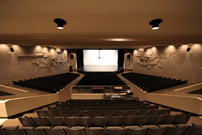
We are very proud of our auditorium. It is a unique facility in the DSBN as well as the Niagara Region. It is used by both our school, our feeder schools, and many community groups. In order to maintain its’ current condition, we ask that the following rules are observed.

1) Food and drinks are not allowed in the auditorium. (Water bottles are an exception)
2) Please keep your feet off the seats and seat backs.
3) Sound and lighting equipment can only be used with teacher/adult supervision.
4) Only students trained and under supervision are allowed to work on the flies.
5) Restore the space. Any equipment used needs to be returned to the designated place after use.
5) All trash should be picked up.
6) Please do not touch the cyclorama (cyc) or any of the curtains. By touching the cyc, you are destroying possible lighting effects for the shows.
7) No one is allowed on the catwalk, in the sound/lighting booths, or under the stage without permission and adult supervision.
8) If you have ongoing use of props, they are to be neatly and compactly stored far into the wings between uses. Keep access to the stairs and doors clear.
9) Students share the responsibility of maintaining the auditorium. Communicate the rules to your friends.

